VISITOR MANAGEMENT SYSTEM USING
SERVICENOW

Milestone 4: Notifications and Dashboard Monitoring
Objective
Improve communication and visitor tracking by sending automated email notifications and providing real-time dashboard insights.

Step 1: Create Email Notifications Using Flow Designer
Purpose
Automatically notify stakeholders whenever a visitor request is submitted or its status changes.
Navigation
Flow Designer → Create Flow
Flow 1: Visitor Request Submitted
Trigger
Visitor record created
Recipient
Employee Host, Visitor

Email Contents
- Visitor Name
- Company Name
- Visit Date
- Purpose of Visit
- Request Status
Result
The employee host receives an email notification whenever a new visitor request is submitted.
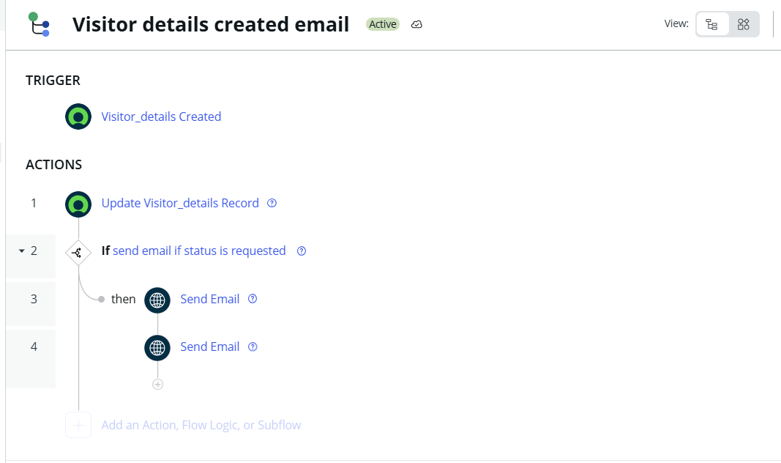

Step 2: Create Status Update Notifications
Trigger
Visitor Status Updated
Recipients
- Employee Host
- Visitor
Email Contents
- Visitor Name
- Visit Date
- Current Status
- Employee Host
Status Notifications
- Approved
- Rejected
- Checked In
- Checked Out
Result
Relevant users receive automated email updates whenever the visitor request status changes.
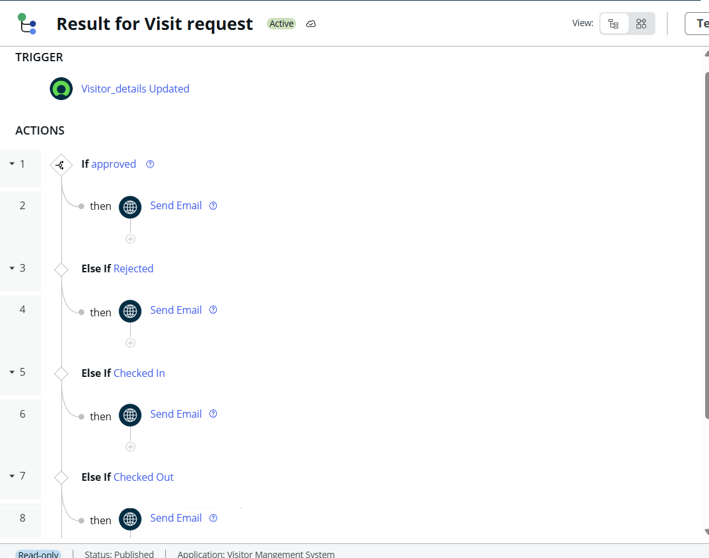

Step 3: Create Visitor Management Dashboard
Purpose
Provide administrators with a centralized view of visitor activities and request statuses.
Navigation
Platform Analytics → Dashboards
Create New Dashboard
Dashboard Name
Visitor Management System Dashboard
Widgets Added
- Total Visit Requests
- Approved Requests
- Rejected Requests
- Checked In Visitors Count
- Currently Checked In Visitors List
- Checked Out Visitors Count
- Checked Out Visitors List
Purpose
The dashboard provides real-time visibility into visitor requests, approvals, rejections, check-ins, and check-outs, enabling efficient monitoring and management of visitor activities.

Result
Administrators can quickly track visitor statistics and view active and completed visits from a single dashboard.

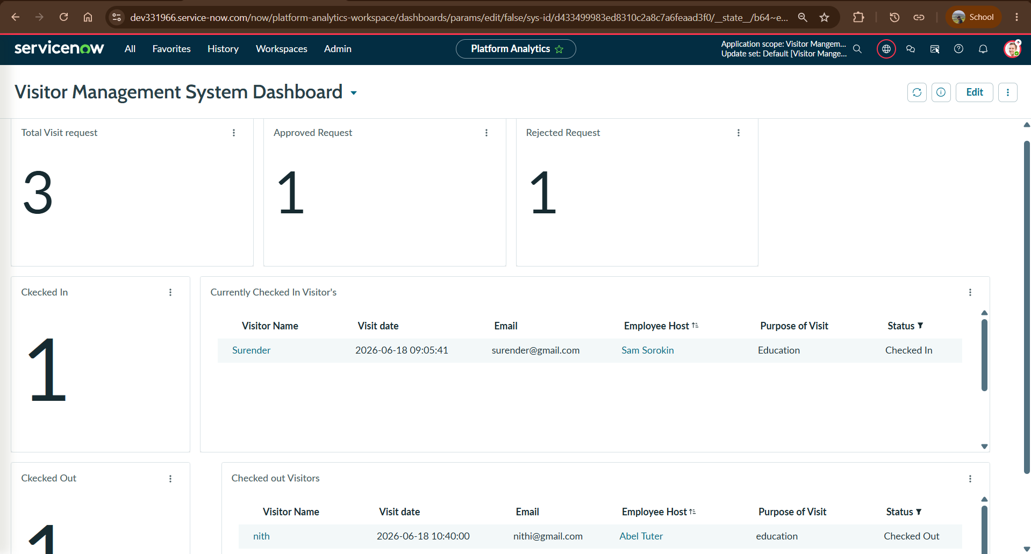

Step 4: Verify Email Notifications
Purpose
Test and verify that email notifications are sent successfully when visitor-related events occur.
Testing Performed
- Submitted a new visitor request.
- Updated visitor status to Approved.
- Updated visitor status to Rejected.
- Performed Check In operation.
- Performed Check Out operation.
Verification
Confirmed that email notifications were delivered to the visitor's registered email address with the correct visitor details and status information.
Result
Email notifications were successfully triggered through Flow Designer and delivered to visitors at each stage of the visitor management process.

Requested:
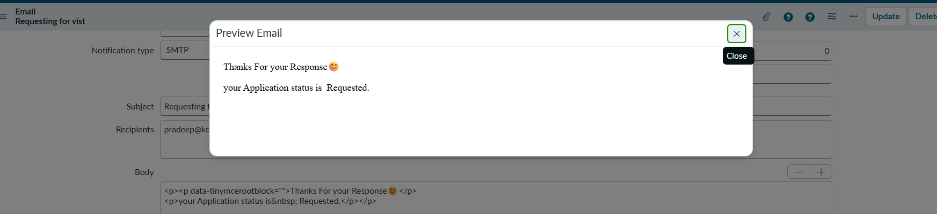

Approved:

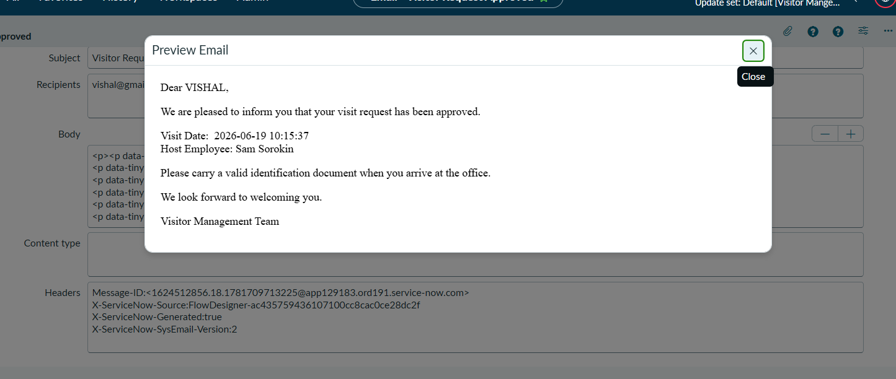

Rejected:
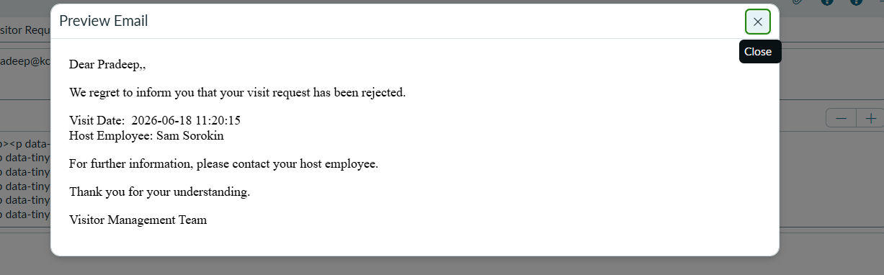

Checked-In: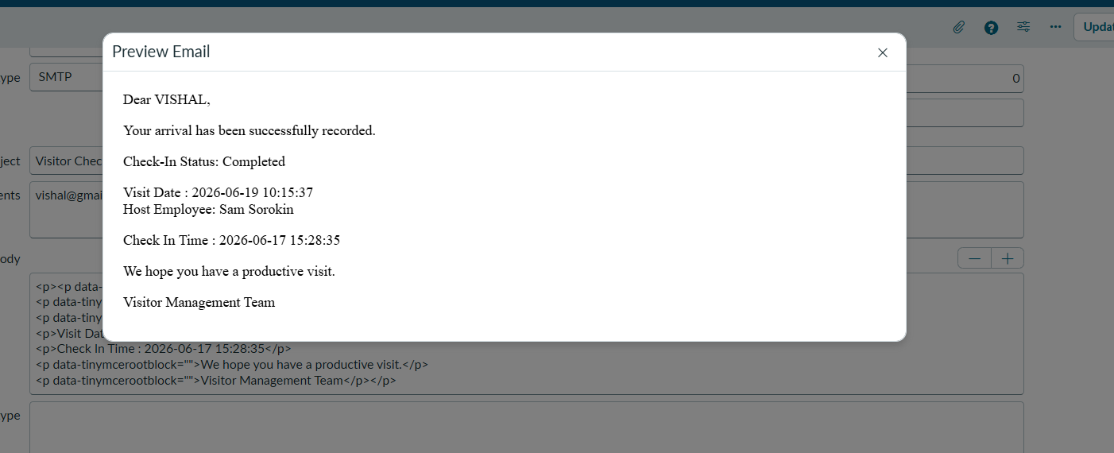

Checked-Out:
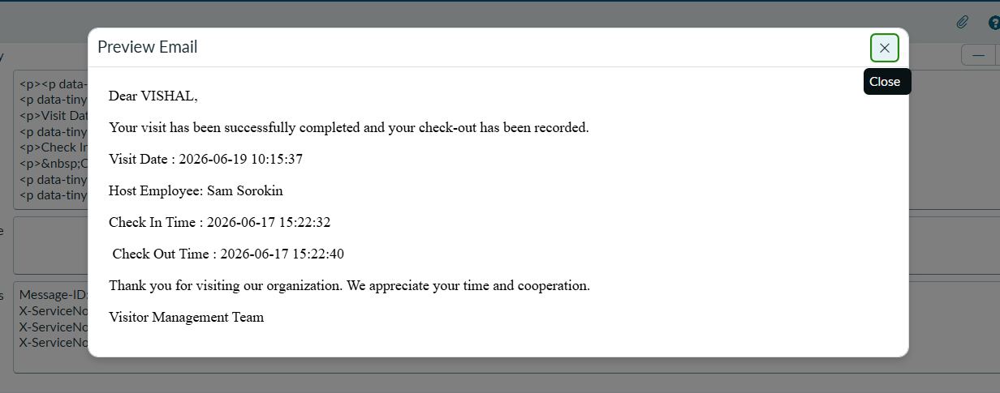

Learning Outcomes
- Created and configured Flow Designer email notifications.
- Verified email delivery and notification processing.
- Designed and developed a Visitor Management Dashboard.
- Configured dashboard widgets for visitor monitoring.
- Learned real-time tracking and visualization of visitor activities.
- Improved reporting and analytics through dashboard insights.

